**Course: AI in Education.**

**Title: Adapting pedagogy for AI.**

**Name: Fatima Alaryani.**

**ID: 200116410.**

**The names of the AI tools and services used to generate the content are:**

1. **For a summary, outcomes, and voiceovers:** [Chatpdf](https://www.chatpdf.com/).
2. **For writing: Grammarly.**
3. **For visuals:** [Microsoft](https://www.bing.com/images/create?FORM=IRPGEN) **Designer.**
4. **For bullet points, visuals, and voiceovers:** [ChatGPT](https://chat.openai.com/).

|  |
| --- |
| **Learning Outcome 1:****Understanding** **the Evolution of Learning Theories in the AI Era.** |
| **Outcome 1.1**: Impacts Of Integration of AI in Constructivist Learning Approaches. |
| **Outcome 1.2**: Impacts Of the Behaviorist Learning Theories Enhanced by AI Technology. |
| **Outcome 1.3**: Introduce Sociocultural Perspectives on AI-driven education. |
| **Learning Outcome 2:** **leveraging Personalized Learning Experiences with AI.** |
| Outcome 2.1:  Tailoring Instruction to Individual Student Needs. |
| Outcome 2.2:  Enhancing Interactivity through AI-Powered Tools. |
| Outcome 2.3:  Introduce Adaptive Learning Strategies for Increased Engagement. |
| **Learning Outcome 3:** **Understanding Paradigm Shift in Education**:  **Symbiotic Integration of AI and Pedagogy.** |
| Outcome 3.1:  Identify AI as a Catalyst for Educational Transformation. |
| Outcome 3.2:  Engaging and Effective Learning Environments with AI. |
| Outcome 3.3: Differentiated Instruction and AI: A New Age of Education. |

**LO 1: Learning Outcome 1: Identify the Impacts Of the Evolution of Learning Theories in the AI Era.**

The final product will be an AI-generated Video(s)

**Learning Outcome 1.1: Impacts Of Integration of AI in Constructivist Learning Approaches.**

**Channel**: Video(s)

**Duration**: 3 to 5 min.

**On-screen Content:**

**Text**: 

* **Facilitating Inquiry**: AI tools like Perplexity.ai and ChatGPT can access vast resources, enabling students to explore topics independently and begin their inquiry process.
* **Personalized Learning**: AI-driven platforms adapt to individual learners' needs, allowing students to construct knowledge at their own pace and according to their level of understanding.
* **Problem-solving**: AI-powered simulations and virtual environments engage students in authentic problem-solving activities central to constructivist learning.
* **Scaffolding**: AI technologies offer tailored support to students, helping them progressively build their understanding and fill in knowledge gaps.
* **Knowledge Visualization**: Tools like Socrat.ai help organize complex information visually, aiding students in making connections and developing a more profound understanding.
* **Reflection and Metacognition**: AI-driven questioning supports students in reflecting on their learning process, enhancing metacognitive skills, and promoting more bottomless knowledge construction.

**Supporting Image(s)**:

**Link Image(s) Source:**

* <https://th.bing.com/th/id/OIG2.TMbUErPHvmDuNiEek15u?pid=ImgGn>
* <https://th.bing.com/th/id/OIG4.VKG.UqaZtJz2q0Mzp9n1?w=1024&h=1024&rs=1&pid=ImgDetMain>

**Voiceover**:

**Facilitating Inquiry**

"In the world of education, AI tools like Perplexity.ai and ChatGPT are revolutionizing how students engage with knowledge. These platforms offer access to vast, diverse resources, enabling students to embark on their unique paths of inquiry. Imagine a classroom where every question a student thinks of can be explored in depth, where the boundaries of learning are defined not by resources but by curiosity. These AI tools support not just access to information but also guide the students in thinking critically about that information. They encourage an exploratory mindset, which is fundamental in a world where learning to learn is as crucial as learning itself. Through AI, students can start their inquiry process with a few keystrokes, diving into topics that fascinate them, thus fostering a truly personalized learning experience."

**Personalized Learning**

"Personalization is at the heart of modern educational approaches, and AI-driven platforms are leading this transformation. These platforms adapt to each student's learning styles and paces, accommodating different strengths and weaknesses. As students interact with these systems, the AI continuously learns about their needs, modifying educational content to suit their levels of understanding. This method ensures that learning is not a one-size-fits-all model but a tailored journey that respects each student’s pace and potential. From adaptive assessments to dynamic problem sets, AI in education means that no student is left behind, and every student is challenged in ways that are right for them."

**Problem-solving**

"In an educational landscape enriched by AI, problem-solving takes on a new dimension. AI-powered simulations and virtual environments immerse students in scenarios that demand critical thinking, adaptability, and creativity. These tools place students in the heart of complex situations where they must navigate challenges, make decisions, and see the consequences of their actions in real-time. This hands-on approach is central to constructivist learning, where knowledge is not simply transferred but experienced. Through engaging in these authentic problem-solving activities, students develop subject-specific knowledge and transferable skills that prepare them for the unpredictable demands of the future workplace."

**Scaffolding**

"Scaffolding is a critical component of effective teaching, and AI technologies are equipped to provide this at an individual level. AI can offer personalized hints, reminders, and support when students need them. This adaptive assistance helps students build their understanding incrementally, filling in knowledge gaps without overwhelming them. Imagine an AI tutor who guides a student through a complex algebra problem or a historical analysis with the right prompts for encouragement or deeper thinking. This support empowers students to achieve mastery and gain confidence in their abilities, paving the way for academic success and lifelong learning."

**Knowledge Visualization**

"In learning, visual representation can dramatically enhance comprehension and retention. Tools like Socrat.ai revolutionize how students interact with complex data by transforming it into visual formats that are easier to understand and manipulate. Whether it's statistical information, historical timelines, or scientific processes, AI helps organize and display this data in ways that make sense to young minds. AI tools foster a deeper, more intuitive understanding of subjects by aiding students in visualizing knowledge, enabling learners to make connections they might not have otherwise seen."

**Reflection and Metacognition**

"AI-driven questioning and feedback mechanisms reshape how students reflect on their learning processes. By encouraging them to question not just the 'what' but the 'how' of their learning, AI enhances metacognitive skills—those crucial abilities that enable learners to evaluate their understanding and strategies. This reflective practice, supported by AI, leads to deeper knowledge construction and self-awareness in learning. Students learn to think about their thinking, which is instrumental in developing independent, critical, and creative thinkers prepared for modern life and career complexities."

**Enrichment Readings:**

**1. Facilitating Inquiry**

* **Resource Type**: Online databases and research portals.
* **Examples**: **Google Scholar,** **JSTOR** ([JSTOR Home](https://www.jstor.org/)), and **ResearchGate (**[ResearchGate | Find and share research](https://www.researchgate.net/)) offer extensive databases for scholarly articles and research papers. Educational platforms like **Khan Academy (**[Khan Academy | Free Online Courses, Lessons & Practice](https://www.khanacademy.org/)) and **Coursera** ([Coursera | Degrees, Certificates, & Free Online Courses](https://www.coursera.org/)) also provide courses and materials across various subjects.

**2. Personalized Learning**

* **Resource Type**: Adaptive learning software.
* **Examples**: **DreamBox (**[Online Math & Reading Programs for Students | DreamBox Learning](https://www.dreambox.com/))Learning for math, which adapts to student performance in real-time, and **Lexia Core5 Reading** ([Device Setup - Core5 (lexiacore5.com)](https://www.lexiacore5.com/register), which tailors literacy education to student skills.

**3. Problem-solving**

* **Resource Type**: Interactive simulations and virtual labs.
* **Examples: PhET** **Interactive Simulations (**[PhET: Free online physics, chemistry, biology, earth science and math simulations (colorado.edu)](https://phet.colorado.edu/) provides free science and math simulations. Another resource is **Labster (**[Labster | Virtual Labs for Universities and High Schools](https://www.labster.com/))**,** which offers virtual labs for science education.

**4. Scaffolding**

* **Resource Type**: Educational scaffolding tools.
* **Examples**: Scaffolding platforms like **EdPuzzle** ([Edpuzzle](https://edpuzzle.com/)), which allows educators to create interactive video lessons, and **Socrative** ([Home - Socrative](https://www.socrative.com/)), a tool for engaging quizzes and student response systems.

**5. Knowledge Visualization**

* **Resource Type**: Data visualization tools.
* **Examples**: **Tableau** **Public** ([Discover | Tableau Public](https://public.tableau.com/app/discover)) for creating interactive graphs and visual data representations and Infogram for designing engaging infographics and reports.

**6. Reflection and Metacognition**

* **Resource Type**: Reflective journals and feedback apps.
* **Examples**: **Penzu** ([Write In Private: Free Online Diary And Personal Journal | Penzu](https://penzu.com/) )or Journal for reflective writing, which are private and customizable. Feedback and assessment tools like **Peergrade** ([Peergrade - engaging student peer review](https://www.peergrade.io/)) facilitate peer review among students.

**Assessment:**

**1. Facilitating Inquiry**

**Question 1:** What is the primary role of AI tools like Perplexity.ai and ChatGPT in facilitating inquiry in education?

A) To provide answers to all student questions.

B) To enable students to explore topics independently using vast resources.

C) To restrict the topics students can research.

* **Correct Answer:** B

**Question 2:** How do AI tools enhance the inquiry process for students?

A) By limiting access to information.

B) By automating all learning processes.

C) By providing access to a broad range of educational resources.

* **Correct Answer:** C

**2. Personalized Learning**

**Question 1:** How do AI-driven platforms support personalized learning?

A) By providing the same learning pace for all students.

B) By adapting the learning content to meet individual student needs.

C) By focusing solely on group learning strategies.

* **Correct Answer:** B

**Question 2:** What is the critical benefit of personalized learning through AI?

A) Decreases student engagement.

B) Allows students to construct knowledge at their own pace.

C) Encourages a one-size-fits-all approach.

* **Correct Answer:** B

**3. Problem-solving**

**Question 1:** What activities do AI-powered simulations and virtual environments provide?

A) Simplistic games with no educational value.

B) Authentic problem-solving activities central to constructivist learning.

C) Only textbook-based questions and answers.

* **Correct Answer:** B

**Question 2:** How does problem-solving with AI impact students?

A) It discourages active learning.

B) It promotes passive observation.

C) It prepares students for real-world challenges.

* **Correct Answer:** C

**4. Scaffolding**

**Question 1:** What is the purpose of AI in educational scaffolding?

A) To decrease the complexity of learning materials.

B) To provide tailored support that helps students build their understanding.

C) To make learning the same for every student.

* **Correct Answer:** B

**Question 2:** How does AI technology help students with knowledge gaps?

A) By ignoring them.

B) By helping students progressively understand and fill these gaps.

C) By focusing only on advanced students.

* **Correct Answer:** B

**5. Knowledge Visualization**

**Question 1:** What role do tools like Socrat.ai play in knowledge visualization?

A) To complicate the understanding of information.

B) To help organize complex information visually.

C) To eliminate visuals from learning.

* **Correct Answer:** B

**Question 2:** How does visualizing knowledge aid students?

A) It decreases their ability to make connections.

B) It helps students develop a deeper understanding of visual organization.

C) It prevents students from engaging with the content.

* **Correct Answer:** B

**6. Reflection and Metacognition**

**Question 1:** What aspect of learning is enhanced by AI-driven questioning?

A) Rote memorization skills.

B) Reflection and metacognitive skills.

C) The ability to ignore feedback.

* **Correct Answer:** B

**Question 2:** How do reflection and metacognition promote learning?

A) By discouraging students from thinking about their learning process.

B) By encouraging more bottomless knowledge construction and self-awareness.

C) By reducing students’ engagement in their studies.

* **Correct Answer:** B

**End of Screen 1 …………………………………………**

**Learning Outcome 1.2: Impacts Of the Behaviourist Learning Theories Enhanced by AI Technology.**

**Channel**: Video(s)

**Duration**: 3 to 5 min.

**On-screen Content:**

**Text**:

* **Immediate Feedback**: AI platforms provide real-time, personalized feedback on student performance, reinforcing learning and correcting misconceptions.
* **Adaptive Learning**: AI systems tailor content and practice activities to reinforce desired behaviors and skills based on individual performance and progression.
* **Gamification**: AI technologies incorporate gamification elements such as rewards and badges to motivate and reinforce learning and engagement.
* **Progress Monitoring**: AI tools track and analyze students’ progress, enabling educators to effectively provide targeted reinforcement and feedback.
* **Mastery-based Learning**: AI supports mastery learning approaches, ensuring students achieve a deep understanding of concepts before advancing.
* **Data-driven Insights**: AI-generated analytics help educators identify patterns in student performance, informing tailored reinforcement strategies.

**Supporting Image(s)**:

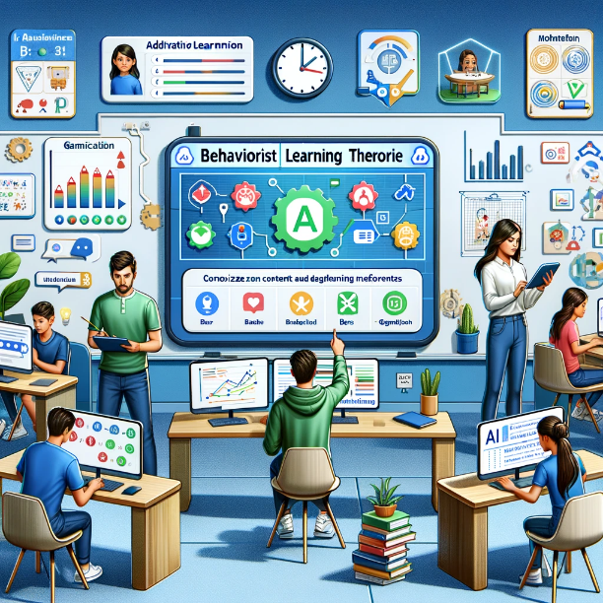

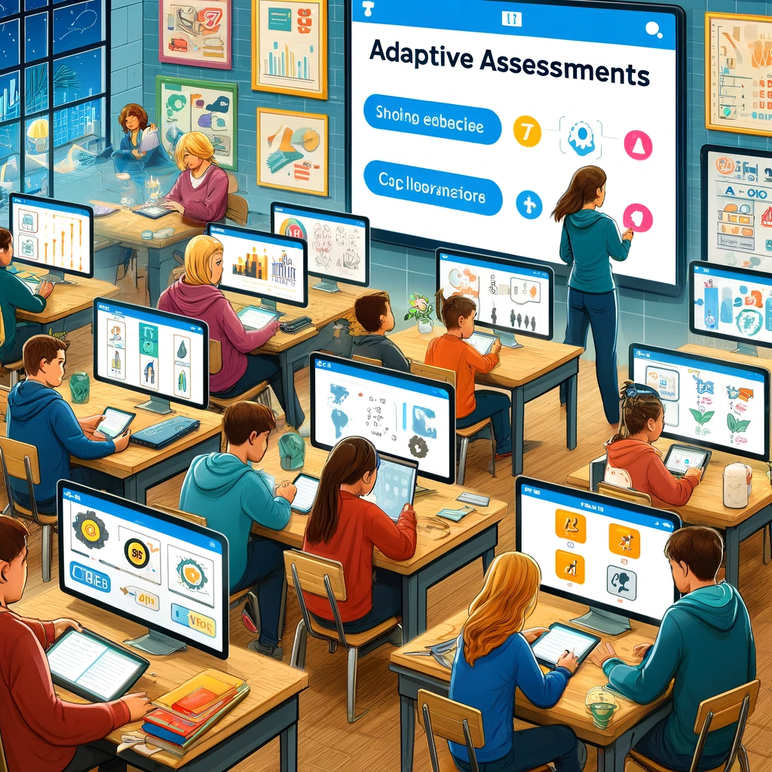

**Link Image(s) Source:**

* [https://files.oaiusercontent.com/file-zGNyHQzS5mztnyjtAvERgcNn?se=2024-04-16T23%3A29%3A03Z&sp=r&sv=2021-08-06&sr=b&rscc=max-age%3D31536000%2C%20immutable&rscd=attachment%3B%20filename%3Da7bd5b27-9b10-474b-9786 274edac95057.webp&sig=UPKOUo8c7bRQiWEmU7yOynXCGMV82USanfSkpjXWegg%3D](https://files.oaiusercontent.com/file-zGNyHQzS5mztnyjtAvERgcNn?se=2024-04-16T23%3A29%3A03Z&sp=r&sv=2021-08-06&sr=b&rscc=max-age%3D31536000%2C%20immutable&rscd=attachment%3B%20filename%3Da7bd5b27-9b10-474b-9786%20274edac95057.webp&sig=UPKOUo8c7bRQiWEmU7yOynXCGMV82USanfSkpjXWegg%3D)
* <https://files.oaiusercontent.com/file-0On29sy7Jbsfq4kSZe1MXroW?se=2024-04-02T14%3A13%3A36Z&sp=r&sv=2021-08-06&sr=b&rscc=max-age%3D31536000%2C%20immutable&rscd=attachment%3B%20filename%3Da3af28b7-94ed-4f99-81f7-55373bdeaf2c.webp&sig=B8rLsgkWUV8qtsgevuomVlsg9HNxndE7Jy5ADj2tNBI%3D> .

**Voiceover**:

**Immediate Feedback**

"In today’s digital classrooms, AI platforms are revolutionizing the feedback process by providing real-time, personalized insights into student performance. Imagine a classroom where the moment a student makes an error, a system immediately identifies and corrects this misconception. This instant feedback is crucial for rectifying errors and reinforcing learning at the engagement point. AI systems analyze responses to pinpoint where a student may struggle and provide customized feedback to guide them toward correct understanding. This continuous, immediate feedback loop ensures that learning is dynamic and interactive, helping students adjust their learning strategies and understand concepts more thoroughly."

**Adaptive Learning**

"Adaptive learning technology, powered by AI, personalizes the educational experience for each student. As students interact with the curriculum, AI systems assess their performance and learning pace, adjusting the content and practice activities in real-time. This tailored learning approach ensures that each student is neither under-challenged nor overwhelmed. The AI continually adapts, presenting new challenges optimally suited to advance the learner's skills and knowledge, effectively reinforcing desired behaviours and skills. This adaptive mechanism ensures that every student experiences a learning journey customized to their needs, maximizing their learning potential."

**Gamification**

"AI technologies are transforming traditional learning environments by integrating gamification elements that make education more engaging and interactive. By incorporating rewards, badges, and interactive challenges, AI systems make learning a more enjoyable and motivating experience. Gamification taps into the natural human drive for competition and achievement, encouraging students to engage more deeply with the material. These AI-driven platforms track progress and provide rewards at just the right moments to maximize motivation, making learning feel less like a chore and more like a rewarding game."

**Progress Monitoring**

"With the aid of AI tools, the daunting task of monitoring student progress becomes streamlined and effective. AI systems meticulously track and analyze each student’s progress through the curriculum, providing educators with detailed insights into the learning journey of their classes. This technology allows teachers to identify who is excelling and who might need extra support, enabling them to target interventions effectively. By offering a clear view of student achievements and challenges, AI-powered progress monitoring helps educators tailor their teaching strategies to meet the needs of their students better."

**Mastery-based Learning**

"AI is at the forefront of promoting mastery-based learning, focusing on depth of understanding rather than speed of progression. AI platforms ensure students comprehensively understand concepts before moving on to more advanced material. This approach avoids the common pitfalls of traditional education models that often push students forward before they are ready. AI systems assess mastery through interactive assessments and practice tasks, ensuring that students build a solid foundation of knowledge and skills. This thorough comprehension is crucial for long-term academic success and is a cornerstone of AI-enhanced education."

**Data-driven Insights**

"In modern education, AI-generated analytics play a pivotal role in shaping how teaching is delivered. These systems provide educators with data-driven insights by analyzing student performance patterns across various metrics. This information is invaluable for developing targeted reinforcement strategies that cater to the classroom's needs. By identifying trends and outliers, educators can implement interventions that are informed by reliable, empirical data, ensuring that each student benefits from teaching strategies that are evidenced-based and highly effective**."**

**Enrichment Readings:**

**1. Immediate Feedback**

* **Resource Type**: Real-time feedback tools.
* **Examples**: Platforms like **Kahoot!** ([Enter Game PIN - Kahoot!](https://kahoot.it/)) and **Quizizz** ([Quizizz | Free Online Quizzes, Lessons, Activities and Homework](https://quizizz.com/?lng=en)) allow real-time quizzes with instant feedback, which is helpful for classrooms and remote learning.

**2. Adaptive Learning**

* **Resource Type**: Adaptive learning software.
* **Examples**: **DreamBox** (for Mathematics) and **Smart Sparrow** ([Smart Sparrow](https://www.smartsparrow.com/)), which adapt their instructional content to the learner's pace and understanding.

**3. Gamification**

* **Resource Type**: Gamification in education tools.
* **Examples**: **Duolingo** () for language learning and **Classcraft** ([Classcraft - Relationships are everything.](https://www.classcraft.com/)) for general education, use game mechanics to increase student engagement.

**4. Progress Monitoring**

* **Resource Type**: Student progress tracking software.
* **Examples**: **Prodigy** [**https://play.prodigygame.com**](https://play.prodigygame.com) (Math game) and platforms like **Edmodo** <https://www.edmodo.com/lander> that allow teachers to monitor and manage classroom activities and student progress.

**5. Mastery-based Learning**

* **Resource Type**: Mastery learning platforms.
* **Examples**: **Khan Academy** offers practice exercises, instructional videos, and a personalized learning dashboard that empowers learners to study independently in and outside the classroom.

**6. Data-driven Insights**

* **Resource Type**: Educational analytics tools.
* **Examples**: **Google Classroom's** analytics and platforms like **Canvas** ([Login](https://canvas.instructure.com/login/canvas) or **Blackboard** ([Educational Technology Services | Blackboard | North America](https://www.blackboard.com/)) provide detailed reports on student activities and performance.

**Assessment**

**1. Immediate Feedback**

**Question 1:** What is the primary benefit of AI platforms providing real-time, personalized feedback in an educational setting?

A) To delay student learning

B) To reinforce learning and correct misconceptions immediately

C) To decrease student participation

* **Correct Answer:** B

**Question 2:** How does immediate feedback from AI platforms impact student performance?

A) Negatively, by providing too much information

B) Positively, by allowing quick corrections and understanding

C) It has no impact on performance

* **Correct Answer:** B

**2. Adaptive Learning**

**Question 1:** What is the purpose of AI systems in adaptive learning?

A) To provide the exact content to every student

B) To tailor content and activities based on individual student performance and needs

C) To increase the complexity of tasks for all students equally

* **Correct Answer:** B

**Question 2:** Which of the following is a crucial feature of adaptive learning platforms?

A) Decreased student engagement

B) Customization of learning experiences

C) Uniform teaching methods

* **Correct Answer:** B

**3. Gamification**

**Question 1:** How do AI technologies use gamification to enhance learning?

A) By reducing the number of educational activities.

B) By incorporating elements such as rewards and badges.

C) By eliminating interactive elements from education.

* **Correct Answer:** B

**Question 2:** What is the primary goal of gamification in education?

A) To discourage learning.

B) To complicate the learning process.

C) To motivate and engage students more profoundly.

* **Correct Answer:** C

**4. Progress Monitoring**

**Question 1:** What is the primary function of AI tools in progress monitoring?

A) To ignore data on student performance

B) To provide irrelevant feedback to educators

C) To track and analyze students' progress effectively

* **Correct Answer:** C

**Question 2:** How does effective progress monitoring benefit teachers?

A) Limits the information available for making instructional decisions.

B) Helps in providing targeted reinforcement and feedback.

C) Encourages a one-size-fits-all approach to education.

* **Correct Answer:** B

**5. Mastery-based Learning**

**Question 1:** What does mastery-based learning ensure about student learning?

A) Students progress without understanding the material.

B) Students achieve a deep understanding of concepts before advancing.

C) Learning is based only on the teacher's schedule.

* **Correct Answer:** B

**Question 2:** How does AI support mastery-based learning approaches?

A) By rushing students through learning modules.

B) By ensuring students master each concept at their own pace.

C) By focusing solely on group learning dynamics.

* **Correct Answer:** B

**6. Data-driven Insights**

**Question 1:** What is the role of AI-generated analytics in education?

A) To confuse educators with complex data

B) To help educators identify patterns in student performance

C) To reduce the amount of data available to educators

* **Correct Answer:** B

**Question 2:** How can data-driven insights from AI enhance teaching strategies?

A) By providing less information about student needs

B) By informing tailored reinforcement strategies

C) By promoting a standardized approach for all students

* **Correct Answer:** B

**End of Screen 2 …………………………………………**

**Learning Outcome 1.3: Introduce Sociocultural Perspectives on AI-Driven Education**

**Channel**: Video(s)

**Duration**: 3 to 5 min.

**On-screen Content:**

**Text**:

* **Global Connections**: AI-driven platforms facilitate interactions among students from diverse cultural backgrounds, fostering collaboration and co-construction of knowledge.
* **Language Translation**: AI-powered tools break down linguistic barriers, enabling students from different language backgrounds to communicate and collaborate effectively.
* **Cultural Insights**: AI technologies provide access to various cultural perspectives, enriching students’ understanding of global contexts and diverse viewpoints.
* **Project-Based Learning**: AI tools assist in designing interdisciplinary, culturally inclusive projects that integrate diverse perspectives and promote sociocultural learning.
* **Inclusive Design**: AI-driven systems ensure learning experiences are accessible to students with diverse needs and backgrounds, supporting a sociocultural approach to education.
* **Enhanced Collaboration and Relationship-Building**: AI integration supports the development of empathy and social skills, which are crucial in multicultural and diverse educational settings.

**Supporting Image(s)**:

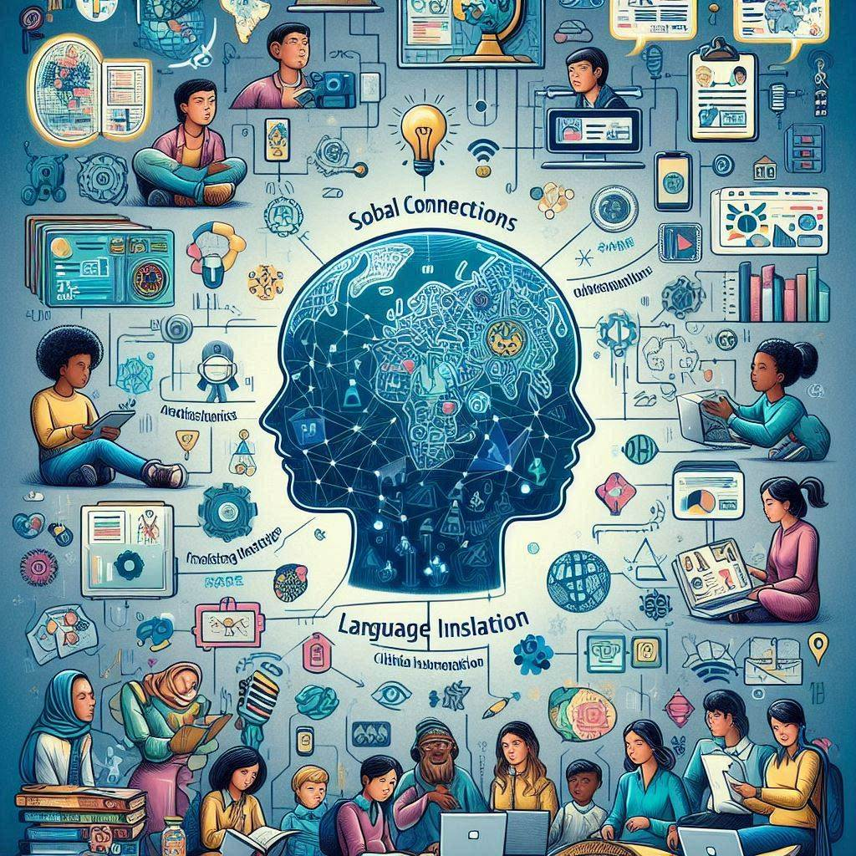



**Link Image(s) Source:**

* <https://th.bing.com/th/id/OIG4.SNE2JbNe5nb_CR_uJUgj?w=1024&h=1024&rs=1&pid=ImgDetMain>
* <https://th.bing.com/th/id/OIG2.oMiykuePN01AZy9KFcvR?w=1024&h=1024&rs=1&pid=ImgDetMain>

**Voiceover:**

**Global Connections**

"In a world more connected than ever, AI-driven platforms are pivotal in bridging the gap between students from diverse cultural backgrounds. These platforms facilitate interaction and deep, meaningful collaboration across continents, enabling the co-construction of knowledge that transcends geographical boundaries. Imagine a classroom that extends globally, where students from different corners of the world come together to solve problems, share insights, and enrich each other's learning experiences. Through AI, students can engage in real-time discussions, work on group projects, and create a shared learning environment that celebrates diversity and fosters global understanding. This global network, powered by AI, is not just preparing students to be part of the world but to take an active role in shaping it."

**Language Translation**

"In today’s multicultural classroom, communication barriers can hinder collaboration and understanding. AI-powered language translation tools are transforming this landscape by allowing students from different linguistic backgrounds to communicate seamlessly. These tools provide real-time, accurate spoken and written text translations, enabling clear and effective communication across language divides. Whether during a live discussion, collaborative project, or peer feedback session, AI ensures that every student's voice is heard and valued, regardless of their native language. This breakthrough in educational technology enhances collaboration and deepens students' connections with one another, promoting a more inclusive learning environment."

**Cultural Insights**

"AI technologies have the unique capability to open windows to the world, providing students with rich cultural insights that broaden their horizons. Through virtual reality tours, interactive simulations, and culturally diverse curricula, AI helps students explore and understand different cultural perspectives. These experiences enrich students’ global awareness and foster a deeper appreciation of the world’s diverse communities. By integrating varied cultural viewpoints into the learning process, AI enriches the curriculum and prepares students to operate globally, making education a tool for personal growth and a bridge to worldwide understanding."

**Project-Based Learning**

"AI tools are revolutionizing project-based learning by facilitating the design of interdisciplinary projects that incorporate diverse cultural and sociocultural perspectives. These projects challenge students to think critically and creatively while considering multiple viewpoints. AI assists educators in crafting projects that are not only academically rigorous but also culturally inclusive, promoting a learning environment that values every student’s background. Through AI, projects can be tailored to reflect the complex interplay of global influences, preparing students to engage with and contribute to a world where interdisciplinary and multicultural competencies are paramount."

**Inclusive Design**

"AI-driven systems are at the forefront of creating inclusive educational environments that cater to students with a wide range of needs and backgrounds. These systems use adaptive technologies to customize learning experiences, ensuring that educational materials are accessible to everyone, including those with disabilities. Whether through speech-to-text capabilities, personalized learning paths, or visually adapted content, AI ensures all students have the necessary resources to succeed. This approach not only supports students with specific needs but also builds a classroom culture that is fundamentally fair and inclusive, reflecting a deep commitment to social equity in education."

**Enhanced Collaboration and Relationship-Building**

"AI integration in educational settings does more than just facilitate learning; it enhances the fabric of interpersonal interactions. By supporting collaborative projects that require empathy and understanding, AI helps develop crucial social skills needed in diverse educational environments. Tools that simulate social scenarios or provide platforms for group interaction allow students to practice and develop these skills in a safe, controlled environment. AI’s role in nurturing these competencies is critical as it helps cultivate a new generation of learners who are not only academically proficient but are also empathetic and culturally aware citizens of the world."

**Enrichment Readings:**

**1. Global Connections**

* **Resource Type**: International collaboration platforms.
* **Examples**: **ePals** ([ePals](https://www.epals.com/) ) and **PenPal Schools** ([PenPal Schools is now Go Pangea](https://www.gopangea.org/penpal-schools-vs-go-pangea)) connect students globally to work on projects and exchange cultural insights.

**2. Language Translation**

* **Resource Type**: AI language translation tools.
* **Examples**: **Google Translate** and **Microsoft Translator** can be integrated into educational platforms to facilitate multilingual communication.

**3. Cultural Insights**

* **Resource Type**: Cultural exchange and learning websites.
* **Examples**: **National Geographic Kids** ([National Geographic Kids](https://kids.nationalgeographic.com/)) and **Project Explorer** ([Project Explore (oxfordonlinepractice.com)](https://projectexplore.oxfordonlinepractice.com/) offer resources and projects that provide cultural insights for students.

**4. Project-Based Learning**

* **Resource Type**: Platforms supporting project-based learning.
* **Examples: Edutopia (**[Edutopia - What Works in Education](https://www.edutopia.org/)) and **Buck Institute** ([Home (buckinstitute.org)](https://www.buckinstitute.org/)) for Education provide extensive resources and guides on implementing project-based learning.

**5. Inclusive Design**

* **Resource Type**: Accessibility tools for education.
* **Examples**: **Microsoft Learning Tools (**[Digital Learning Tools | Microsoft Education](https://www.microsoft.com/en-us/education/products/learning-tools)) and **Apple’s** accessibility features help tailor educational experiences to diverse student needs.

**6. Enhanced Collaboration and Relationship-Building**

* **Resource Type**: Tools for enhancing collaboration and social skills.
* **Examples**: **Slack for Education (**[Slack is your productivity platform | Slack](https://slack.com/)) and **Microsoft Teams for Education** facilitate collaboration through chat and project management tools designed for educational settings.

**Assessment:**

**Global Connections**

**Question 1:** What is the primary role of AI-driven platforms in facilitating global connections among students?

A) To limit student interaction to local communities

B) To foster collaboration and knowledge sharing among students from diverse cultural backgrounds

C) To restrict communication to written forms only

* Correct Answer: B

**Question 2:** How do global connections enhance student learning?

A) By decreasing exposure to different cultures

B) By increasing understanding and cooperation across cultures

C) By focusing only on local issues

* Correct Answer: B

**2. Language Translation**

Question 1: What barrier do AI-powered language translation tools help overcome in education?

A) Cultural differences

B) Linguistic barriers

C) Technological limitations

* Correct Answer: B

Question 2: How does breaking down linguistic barriers affect student collaboration?

A) Reduces the effectiveness of communication

B) Enables students from different language backgrounds to communicate effectively

C) Isolates students by language groups

* Correct Answer: B

**3. Cultural Insights**

**Question 1:** What do AI technologies provide that enriches students’ understanding of global contexts?

A) Access to a limited set of textbooks

B) Various cultural perspectives and insights

C) Uniform educational content

* Correct Answer: B

**Question 2:** Why is exposure to different cultural perspectives critical in education?

A) It narrows students' worldviews

B) It enriches students' global understanding and fosters empathy

C) It has no impact on educational outcomes

* Correct Answer: B

**4. Project-Based Learning**

**Question 1**: How do AI tools assist in project-based learning?

A) By providing outdated educational methods

B) By designing interdisciplinary projects that integrate diverse perspectives

C) By limiting collaboration among students

* Correct Answer: B

**Question 2:** What is a crucial benefit of AI-supported project-based learning?

A) Promotes passive learning

B) Encourages sociocultural learning and inclusion

C) Discourages creativity

* Correct Answer: B

**5. Inclusive Design**

**Question 1:** What is the goal of AI-driven systems in ensuring inclusive design in education?

A) To create barriers to learning

B) To make learning experiences accessible to students with diverse needs

C) To standardize learning experiences for all students

* Correct Answer: B

**Question 2:** How does inclusive design impact the learning environment?

A) Decreases student engagement

B) Supports a sociocultural approach to education

C) Reduces educational content quality

* Correct Answer: B

**6. Enhanced Collaboration and Relationship-Building**

**Question 1:** What aspect of student development do AI integrations support in multicultural educational settings?

A) The development of empathy and social skills

B) The reinforcement of stereotypes

C) The preference for individual work over teamwork

* Correct Answer: A

**Question 2:** Why is enhancing collaboration and relationship-building important in diverse educational settings?

A) It limits student interactions

B) It prepares students to operate effectively in a global society

C) It focuses only on academic achievements

* Correct Answer: B

**End of Screen 3 …………………………………………**

**The end of learning outcome 1**

**LO 2: Learning Outcome 2: Introduce Personalized Learning Experiences with AI.**

The final product will be an AI-generated Video(s)

**Learning Outcome 2.1: Tailoring Instruction to Individual Student Needs.**

**Channel**: Video(s)

**Duration**: 3 to 5 min

**On-screen Content**:

**Text**:

* **Individualized Learning Paths:** AI systems analyze student data to create customized learning experiences that align with each student’s strengths, weaknesses, and learning pace.
* **Real-Time Adjustments:** AI tools can modify educational content in real-time based on student interactions and performance, ensuring that the instruction matches the learner's current needs.
* **Personalized Feedback:** AI is being leveraged to provide instant and tailored feedback to students, helping them understand concepts more deeply and correcting mistakes quickly.

**Supporting Image(s)**:

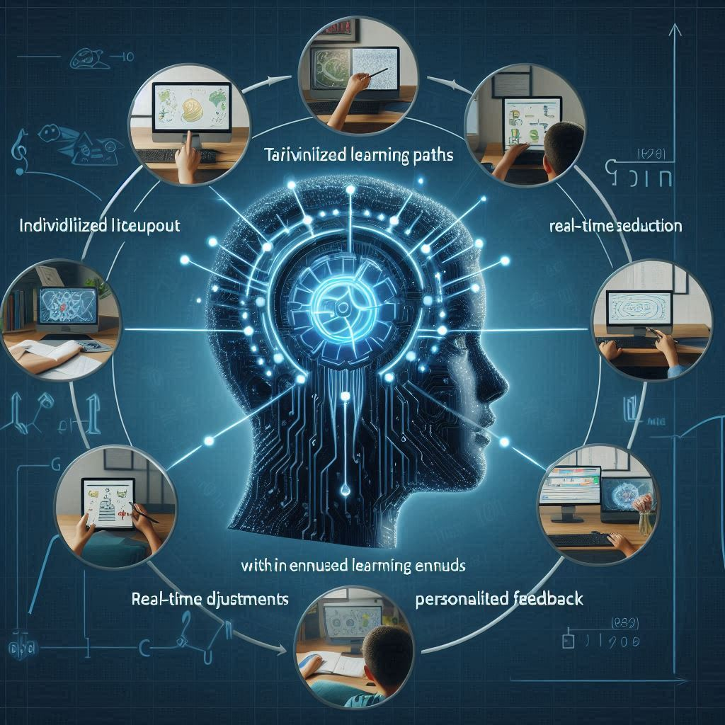

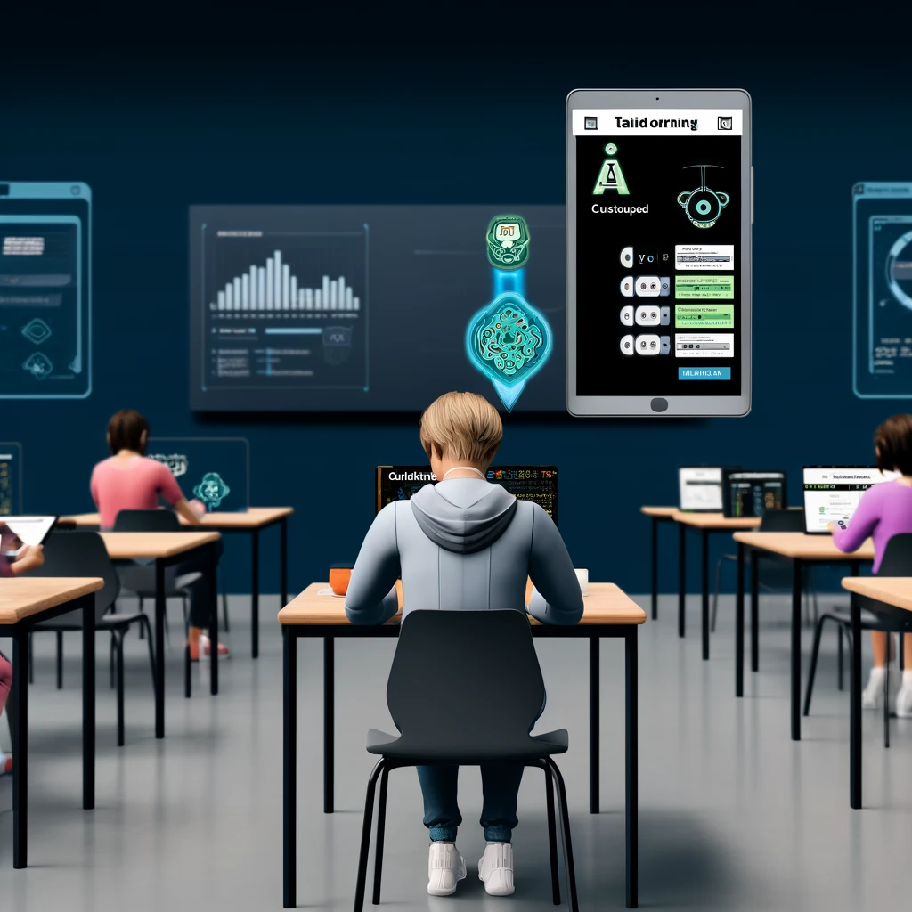

**Link Image(s) Source:**

* [**https://th.bing.com/th/id/OIG2.JGCqeBkK_OQuwUAgp9Pp?pid=ImgGn**](https://th.bing.com/th/id/OIG2.JGCqeBkK_OQuwUAgp9Pp?pid=ImgGn)
* [**https://files.oaiusercontent.com/file-kkasQVzp3zYMGiwyDs7ZAePk?se=2024-04-17T14%3A48%3A13Z&sp=r&sv=2021-08-06&sr=b&rscc=max-age%3D31536000%2C%20immutable&rscd=attachment%3B%20filename%3Dbdfeccf3-b709-4cc1-ad7f-69e385e6af86.webp&sig=2Buy80vaFTPG/s5N5Plai06YgrodcqbB893gZqBHx94%3D**](https://files.oaiusercontent.com/file-kkasQVzp3zYMGiwyDs7ZAePk?se=2024-04-17T14%3A48%3A13Z&sp=r&sv=2021-08-06&sr=b&rscc=max-age%3D31536000%2C%20immutable&rscd=attachment%3B%20filename%3Dbdfeccf3-b709-4cc1-ad7f-69e385e6af86.webp&sig=2Buy80vaFTPG/s5N5Plai06YgrodcqbB893gZqBHx94%3D)

**Voiceover**:

**Individualized Learning Paths**

"In today's classrooms, AI systems are revolutionizing how we approach education by creating individualized learning paths for each student. These intelligent systems meticulously analyze student data, including performance metrics, learning styles, and engagement levels, to tailor the educational experience precisely to each student's strengths and weaknesses. Imagine a learning environment where every lesson perfectly aligns with a student's pace, challenging enough to keep them engaged but not so difficult as to overwhelm them. This personalized approach ensures that every student meets educational standards and excels at their own pace, fostering a deep and lasting understanding of the material."

**Real-Time Adjustments**

"Adaptability is key in the dynamic environment of the classroom. With the integration of AI tools, educational content is no longer static but fluid, capable of changing in real time to suit the immediate needs of each student. As students interact with lessons, AI systems monitor their performance, making instant adjustments to the difficulty level and content presentation. This responsiveness ensures that learning always aligns with the student's current abilities and challenges, making education a truly personalized experience. Such real-time adjustments help maintain an optimal learning curve and prevent students from becoming disengaged or frustrated."

**Personalized Feedback**

"Feedback is a crucial component of effective learning, and AI is transforming this aspect by providing instant and personalized feedback that is crucial for student development. As students work through problems and assignments, AI systems analyze their responses to pinpoint errors and misunderstandings in real time. Instead of waiting days for a teacher’s correction, students receive immediate, tailored feedback that helps them understand their mistakes and learn the correct concepts. This immediate correction cycle accelerates learning, enhances understanding, and builds student confidence, making learning more efficient and effective."

**Enrichment Readings**:

**Individualized Learning Paths**

* **Resource Type**: Adaptive learning platforms.
* **Examples**: DreamBox Learning for math, which tailors problems to the student's level, and Smart Sparrow, which allows for creating adaptive learning experiences across subjects.

**Real-Time Adjustments**

* **Resource Type**: Real-time feedback and adjustment tools.
* **Examples**: Kahoot for real-time quizzes and feedback and platforms like Knewton that adjust educational content dynamically based on ongoing student performance.

**Personalized Feedback**

* **Resource Type**: Tools for instant educational feedback.
* **Examples**: Turnitin provides immediate feedback on writing assignments, and Socrative allows teachers to assess and give feedback instantly during lessons.

**Assessment**

**Individualized Learning Paths**

Question 1: What is the primary purpose of AI systems creating individualized learning paths for students?

A) To standardize the learning experience across all students

B) To customize learning experiences that align with each student’s strengths, weaknesses, and pace

C) To focus only on the students' weaknesses

* Correct Answer: B

Question 2: How do individualized learning paths benefit students?

A) By providing the same level of challenge to all students

B) By adapting to the unique educational needs of each student

C) By limiting access to diverse learning materials

* Correct Answer: B

**Real-Time Adjustments**

Question 1: What role do AI tools play in making real-time adjustments in educational content?

A) To make the content less challenging over time

B) To modify the content based on student interactions and performance

C) To disregard students' immediate learning needs

* Correct Answer: B

Question 2: Why are real-time adjustments necessary in a learning environment?

A) They prevent students from learning at their own pace

B) They ensure the content matches the learner’s current needs and abilities

C) They decrease the efficiency of learning

* Correct Answer: B

**Personalized Feedback**

Question 1: What is the benefit of leveraging AI to provide personalized feedback to students?

A) To delay feedback until the end of the term

B) To help students understand concepts more deeply and correct mistakes quickly

C) To provide generic feedback that applies to all students

* Correct Answer: B

Question 2: How does instant personalized feedback impact student learning?

A) It decreases student motivation and engagement

B) It accelerates the learning process and enhances understanding

C) It confuses students with too much information

* Correct Answer: B

**End of Screen 4 …………………………………………**

**Learning Outcome 2.2:** **Enhancing Interactivity through AI-Powered Tools.**

**Channel**: Video(s)

**Duration**: 3 to 5 min.

**On-screen Content:**

**Text**:

* **Real-time Questioning and Feedback**: AI-powered tools can engage students with real-time questioning, offering immediate feedback that enhances understanding and keeps students actively involved in learning.
* **Interactive Simulations**: Utilize AI to create dynamic simulations that allow students to experiment and interact with virtual environments, enhancing their understanding of complex concepts through practical application.
* **Personalized Learning Experiences**: AI can analyze student performance and preferences to tailor the interactivity of lessons, ensuring that each student's learning experience is optimized to their individual needs.
* **Gamified Learning**: Incorporate gamification elements into educational platforms, using AI to track progress and adapt challenges to maintain student engagement and motivation.
* **Collaborative Tools**: AI can facilitate collaborative learning by connecting students from different backgrounds and skill levels, encouraging interaction through group tasks and projects that are dynamically adjusted based on group performance.
* **Augmented Reality (AR) and Virtual Reality (VR)**: Implement AI-powered AR and VR technologies to create immersive learning experiences that can transform the classroom and offer students a hands-on approach to learning material.
* **Adaptive Assessment Tools**: Develop AI-driven assessments that respond to student inputs, providing tasks of varying difficulty based on their answers, thus keeping students challenged and engaged.

**Supporting Image(s)**:

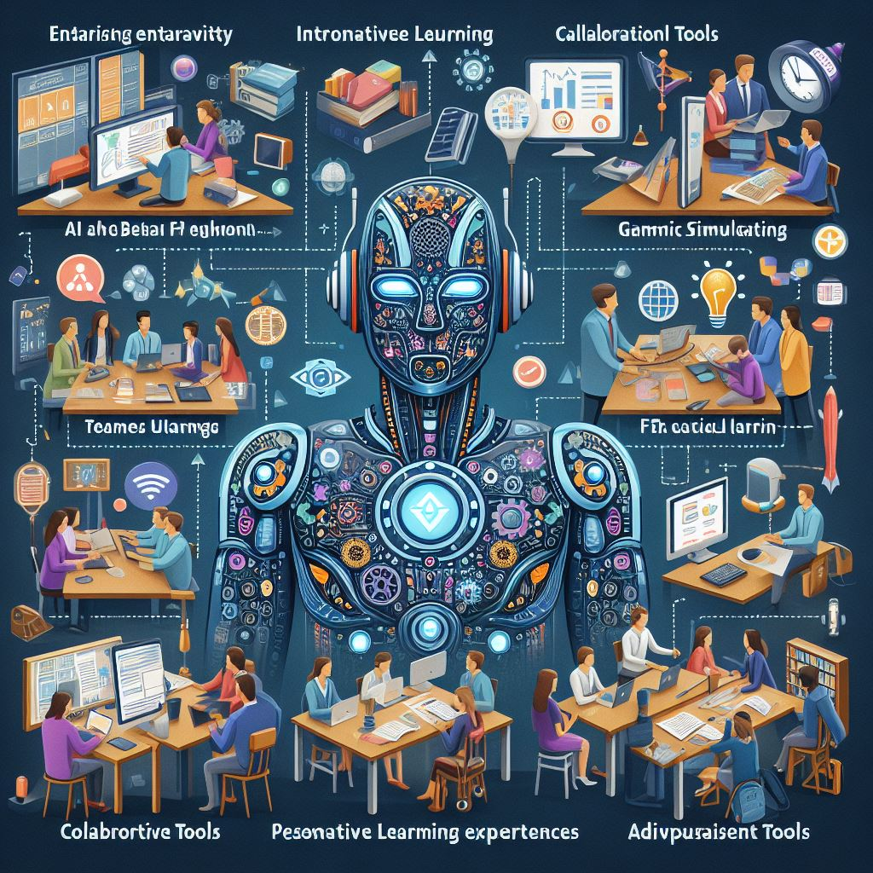

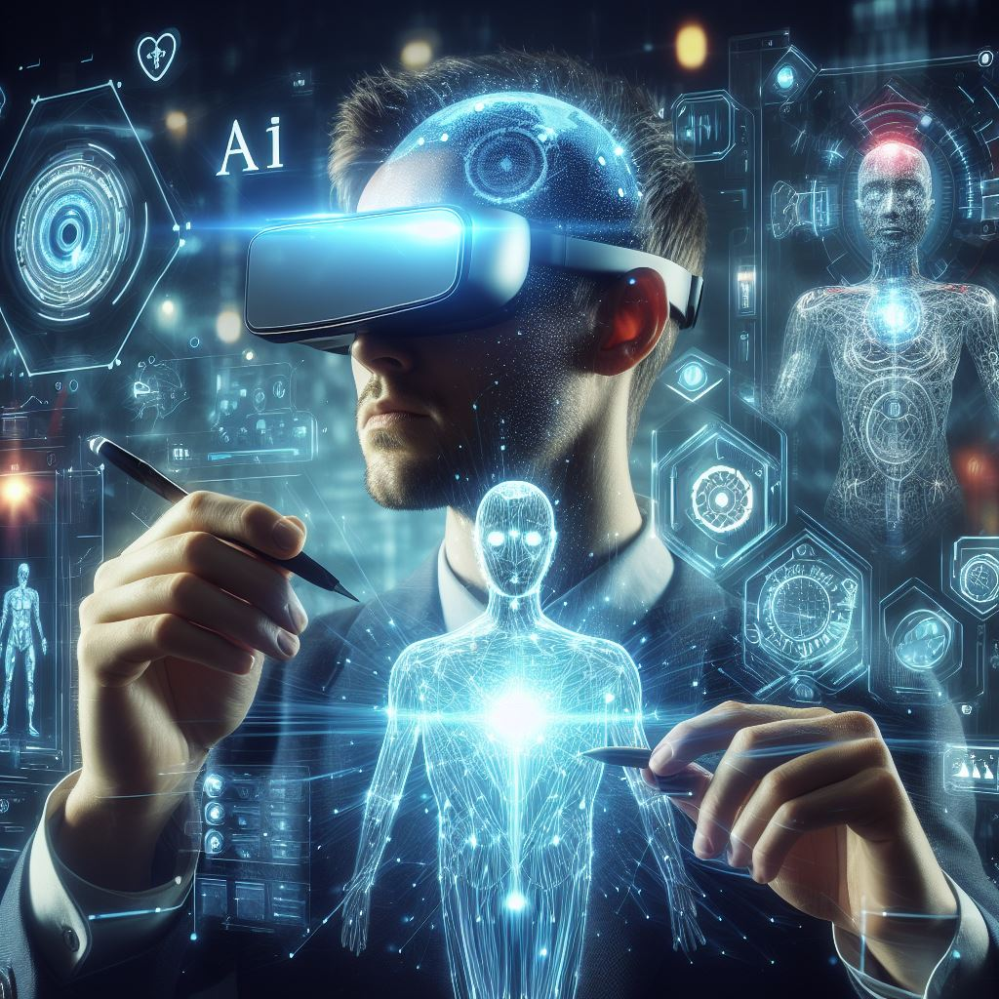

**Link Image(s) Source:**

* <https://th.bing.com/th/id/OIG1.BTeAAWx2QPth4W2bRceN?pid=ImgGn>
* <https://th.bing.com/th/id/OIG2.t7VzvsYmnQaZpEhKP82M?pid=ImgGn>

**Voiceover**:

**Real-time Questioning and Feedback**

"Imagine a classroom where every student receives personalized attention and guidance exactly when they need it. AI-powered tools make this possible through real-time questioning and feedback. AI systems pose questions and challenges as students work through their lessons, immediately analyzing responses to provide instant feedback. This interaction clarifies misunderstandings and keeps students engaged, transforming passive learning into an interactive dialogue. The feedback is tailored to each student's responses, ensuring that it addresses specific areas of confusion and reinforces understanding, making the learning process more effective and responsive."

**Interactive Simulations**

"AI is revolutionizing how students learn about complex concepts through interactive simulations. These AI-driven environments allow students to manipulate variables, see the effects of their decisions, and understand systems in real-time. Whether it’s exploring the laws of physics in a virtual lab or managing ecosystems in a simulated environment, these tools offer hands-on experiences that are both informative and engaging. By enabling students to experiment freely and see the immediate impact of their actions, AI simulations provide a powerful means for active, applied, and deeply immersive learning."

**Personalized Learning Experiences**

"AI technology excels in customizing the learning experience to fit the unique needs of each student. By analyzing data on student performance and learning preferences, AI can tailor the interactivity of lessons to optimize each learner's engagement. This personalization ensures that every student encounters material most effectively for their learning style, whether through visual aids, interactive content, or challenging puzzles. The result is a learning experience that meets students where they are and pushes them towards greater academic achievements."

**Gamified Learning**

"Incorporating gamification elements into educational platforms is a proven strategy to boost student engagement and motivation. AI enhances this approach by tracking progress and adapting challenges in real-time. As students advance through their learning journey, AI dynamically adjusts the difficulty of tasks and integrates rewards at key milestones. This responsive system keeps motivation high and encourages continuous engagement, turning learning into an enjoyable and rewarding game that students are eager to play."

**Collaborative Tools**

"AI-powered tools are transforming traditional classroom dynamics by facilitating effective collaboration among students from diverse backgrounds. These tools enable learners to work together on group projects and tasks that are dynamically adjusted to match their collective skill level and learning pace. AI supports these interactions by managing roles, facilitating communication, and ensuring all students contribute equitably. The collaborative environment AI fosters enhances learning outcomes and builds essential social skills and teamwork capabilities."

**Augmented Reality (AR) and Virtual Reality (VR)**

"Educators can create immersive learning experiences that dramatically enhance student engagement and understanding by implementing AI-powered AR and VR technologies. These technologies transport students into different worlds, times, or situations, allowing them to explore historical events, distant planets, or complex biological processes up close. This hands-on approach supported by AI makes learning vivid and memorable, effectively bridging the gap between theoretical knowledge and practical understanding."

**Adaptive Assessment Tools**

"AI-driven assessments represent a leap forward in educational technology, providing tasks that adapt in real-time to the student's performance. These tools adjust the difficulty of questions based on student responses, ensuring that each learner is adequately challenged but not overwhelmed. This adaptive testing model keeps students engaged and continuously assesses their understanding, allowing for timely interventions and support. It’s a smarter, more efficient way to measure progress and ensure all students progress at their best pace."

**Enrichment Reading**:

* 1. **Real-time Questioning and Feedback:**
     + Resource 1: [Kahoot!](https://kahoot.com/) - A platform for creating interactive quizzes and games that provide real-time feedback to students.
     + Resource 2: [Socrative](https://www.socrative.com/) - An app that allows teachers to engage students with interactive activities and receive instant feedback.
     + Resource 3: [Nearpod](https://nearpod.com/) - A tool for creating interactive lessons with real-time formative assessments and feedback.
  2. **Interactive Simulations:**
     + Resource 1: [PhET Interactive Simulations](https://phet.colorado.edu/)—Offers free interactive math and science simulations for students to explore concepts hands-on.
     + Resource 2: [Labster](https://www.labster.com/)—This site provides virtual lab simulations for biology, chemistry, and more, allowing students to conduct experiments in a virtual environment.
     + Resource 3: [ExploreLearning Gizmos](https://www.explorelearning.com/) - Offers interactive math and science simulations that help students visualize and understand complex concepts.
  3. **Personalized Learning Experiences:**
     + Resource 1: [IXL](https://www.ixl.com/) - An adaptive learning platform that personalizes lessons based on student performance and provides targeted practice.
     + Resource 2: [DreamBox Learning](https://www.dreambox.com/)—This company focuses on personalized math lessons for students, adapting content to individual learning needs.
     + Resource 3: [Cognii](https://www.cognii.com/) - Utilizes AI to provide personalized tutoring and feedback on written responses for language learning.
  4. **Gamified Learning:**
     + Resource 1: [Classcraft](https://www.classcraft.com/) - A platform that gamifies the classroom experience, encouraging student collaboration and engagement.
     + Resource 2: [Quizizz](https://quizizz.com/) is a gamified quiz platform that motivates students to learn through interactive quizzes and challenges.
     + Resource 3: [Prodigy](https://www.prodigygame.com/) is a math game that adapts content to student performance, making learning fun and engaging.
  5. **Collaborative Tools:**
     + Resource 1: [Google Workspace for Education](https://workspace.google.com/education/)—This site offers collaborative tools like Google Docs and Google Slides for students to work on projects together.
     + Resource 2: [Padlet](https://padlet.com/) - A digital canvas that allows students to collaborate, share ideas, and work on projects in real-time.
     + Resource 3: [Flipgrid](https://info.flipgrid.com/) - A video discussion platform that promotes student collaboration and engagement through video responses.
  6. **Augmented Reality (AR) and Virtual Reality (VR):**
     + Resource 1: [Merge EDU](https://mergeedu.com/) - Provides AR and VR educational experiences that immerse students in interactive learning environments.
     + Resource 2: [Google Expeditions](https://edu.google.com/products/vr-ar/expeditions/) - Offers virtual reality field trips and immersive experiences for students to explore various subjects.
     + Resource 3: [ZSpace](https://zspace.com/) is a platform that combines AR and VR for interactive learning experiences in subjects like science and anatomy.
  7. **Adaptive Assessment Tools:**
     + Resource 1: [Edulastic](https://edulastic.com/) - An adaptive assessment platform that adjusts questions based on student responses and provides instant feedback.
     + Resource 2: [Formative](https://goformative.com/) - Teachers can create adaptive assessments and monitor student progress in real-time.
     + Resource 3: [MasteryConnect](https://www.masteryconnect.com/) - Offers adaptive assessments and tools for tracking student mastery and progress.

**Assessment**:

**Real-time Questioning and Feedback**

1. **What is the primary benefit of AI-powered real-time questioning in educational settings?**

A) Increases the time it takes to receive feedback

B) Reduces student interaction during lessons

C) Enhances understanding through immediate feedback **(Correct Answer)**

D) Limits the types of questions students can ask

1. **How does real-time feedback from AI-powered tools impact student learning?**

A) Discourages active participation

B) Delays the learning process

C) Promotes a passive learning environment

D) Keeps students actively involved **(Correct Answer)**

**Interactive Simulations**

1. **AI-powered interactive simulations allow students to:**

A) Only observe virtual environments passively

B) Experiment and interact with complex concepts **(Correct Answer)**

C) Avoid engaging with the learning material

D) Focus solely on theoretical knowledge

1. **What is the purpose of using interactive simulations in education?**

A) To reduce classroom interaction

B) To enhance understanding through practical application **(Correct Answer)**

C) To limit student exposure to new technologies

D) To simplify the curriculum content

**Personalized Learning Experiences**

1. **AI customizes learning experiences by analyzing:**

A) Only the teacher's teaching style

B) Randomly selected content

C) Student performance and preferences **(Correct Answer)**

D) Generic educational standards

1. **Personalized learning experiences through AI help ensure that:**

A) All students receive the same lessons

B) Each student's learning is optimized to their needs **(Correct Answer)**

C) Learning progresses at a uniform pace for all

D) Students have reduced interactive opportunities

**Gamified Learning**

1. **Which elements do AI-powered educational platforms incorporate to maintain engagement?**

A) Long lectures and reading assignments

B) Gamification elements like rewards and badges **(Correct Answer)**

C) Standardized tests without feedback

D) Non-interactive video content

1. **How does gamification affect student motivation?**

A) Decreases interest in academic subjects

B) Reduces the need for active participation

C) Increases motivation and engagement **(Correct Answer)**

D) Promotes memorization without understanding

**Collaborative Tools**

1. **AI-powered collaborative tools are used in classrooms to:**

A) Prevent students from working together

B) Facilitate group tasks and projects dynamically **(Correct Answer)**

C) Track only the top-performing students

D) Reduce the diversity of student interactions

1. **Which of the following best describes the function of AI in collaborative learning?**

A) To limit communication among students

B) To disconnect students from diverse backgrounds

C) To encourage interaction through group tasks **(Correct Answer)**

D) To standardize learning across different groups

**Augmented Reality (AR) and Virtual Reality (VR)**

1. **What role do AR and VR play in AI-powered education?**

A) To discourage the practical application of concepts

B) To create immersive learning experiences **(Correct Answer)**

C) To simplify the technology used in classrooms

D) To limit hands-on learning opportunities

1. **How do AR and VR enhance educational experiences?**

A) By providing less engaging content

B) By transforming the classroom with hands-on approaches **(Correct Answer)**

C) By promoting traditional teaching methods

D) By reducing the use of technology in learning

**Adaptive Assessment Tools**

1. **AI-driven assessments adapt to:**

A) The strict curriculum requirements only

B) Student answers to provide tailored challenges **(Correct Answer)**

C) A standardized test format for all students

D) Reducing the frequency of assessments

1. **The purpose of adaptive assessment tools is to:**

A) Decrease the relevance of assessments

B) Keep students challenged and engaged **(Correct Answer)**

C) Simplify the grading process for teachers

D) Encourage memorization over understanding

**End of Screen 5 …………………………………………**

**Learning Outcome 2.3: Introduce Adaptive Learning Strategies for Increased Engagement.**

**Channel**: Video(s)

**Duration**: 3 to 5 min.

**On-screen Content**:

**Text**: 

* **Dynamic Content Adjustment**: Implement AI systems that analyze student interactions and performance in real-time to adjust the difficulty and type of content presented dynamically. This ensures that each student is consistently challenged appropriately, enhancing engagement and preventing frustration or boredom.
* **Personalized Learning Paths**: Utilize AI to create individualized learning paths for students, which adapt based on their progress, strengths, and areas for improvement. This personalization keeps students engaged by focusing on their unique educational needs and goals.
* **Feedback and Support Systems**: Integrate AI-driven feedback mechanisms that provide students instant, personalized feedback on their work. This continuous support helps students understand their learning process more deeply, maintain engagement, and stay motivated to improve.
* **Predictive Analytics**: Employ AI tools that use predictive analytics to forecast students' learning outcomes based on their current performance. This can guide teachers in proactively adjusting instructional strategies and resources to meet student needs better before engagement levels drop.
* **Interactive and Gamified Learning**: Enhance learning platforms with interactive elements and AI-powered gamification to make learning more engaging. Virtual rewards, progress badges, and competitive scenarios can significantly increase student interest and participation.
* **Collaborative Learning Environments**: Develop AI systems that facilitate student collaboration by grouping them based on learning styles and progress. These systems can encourage peer learning and increase engagement through social interaction and collective problem-solving.

**Supporting Image(s)**:

**Supporting Image(s)**:

* <https://th.bing.com/th/id/OIG3.MxKLVfnqvXOI6bAvjmzB?w=1024&h=1024&rs=1&pid=ImgDetMain>
* <https://th.bing.com/th/id/OIG4.MfqS3zEbb2Ygdhls9OKk?pid=ImgGn>

**Voiceover**:

**Dynamic Content Adjustment**

"In an ideal learning environment, every student would be met exactly where they are in their educational journey. Thanks to AI, this is becoming a reality. Dynamic content adjustment utilizes AI systems to analyze student interactions and real-time performance. This intelligent analysis allows the system to dynamically adjust the difficulty and type of content presented to each student. If a student masters a concept quickly, the AI introduces more challenging material to keep them engaged and learning at their peak potential. Conversely, if a student struggles, the content is simplified to reinforce foundational concepts, preventing frustration and disengagement. This tailored approach ensures that learning is always engaging, never too easy or overwhelmingly difficult, thus optimizing the educational experience for each student."

**Personalized Learning Paths**

"Personalized learning paths represent a revolution in educational methods, where each student's unique needs and goals are at the forefront of their educational experience. AI plays a crucial role by analyzing data on students' progress, strengths, and areas for improvement. It then adapts the learning path in real time to match their evolving educational needs. This level of personalization ensures that students remain deeply engaged, as they are neither under-challenged nor overwhelmed. Instead, they experience a learning journey perfectly aligned with their pace and capabilities, making education more effective and enjoyable."

**Feedback and Support Systems**

"Imagine a learning environment where feedback is immediate and deeply personalized. AI-driven feedback systems make this possible. These systems provide instant feedback on student submissions, clarify doubts, and offer suggestions for improvement, all in real-time. This kind of support is invaluable as it helps students understand their learning process on a granular level, allowing them to adjust their strategies and improve continuously. Such immediate and personalized feedback keeps students engaged, motivated, and on track towards achieving their educational goals."

**Predictive Analytics**

"Predictive analytics in education uses AI to transform how educational outcomes are forecasted and managed. AI tools can accurately predict future learning outcomes by analyzing student performance patterns. This foresight enables educators to proactively adjust their teaching strategies and resources to meet each student’s needs. Such predictive capabilities ensure timely and effective interventions, significantly enhancing the learning experience before students even begin to disengage."

**Interactive and Gamified Learning**

"Incorporating AI-powered interactive and gamified elements into learning platforms has transformed traditional education into an engaging, almost game-like experience. Students encounter virtual rewards, earn badges, and participate in educational competitions, which make learning not just a task but an exciting challenge. These elements, driven by sophisticated AI, adapt to the user’s learning pace, increasing difficulty as the student progresses. This approach significantly boosts engagement, making learning fun and addictive for students."

**Collaborative Learning Environments**

"AI also plays a pivotal role in fostering collaborative learning environments. By analyzing individual learning styles and progress, AI systems can effectively group students in ways that optimize their collective learning potential. These groups encourage peer learning and collective problem-solving, leveraging diverse strengths and perspectives. Such environments enhance academic performance and build essential social skills as students engage with each other to tackle common challenges."

**Enrichment Readings** :

1. **Dynamic Content Adjustment:**
   * **Enrichment Resource:** [IXL](https://www.ixl.com/) - An adaptive learning platform that adjusts content difficulty based on student performance in real time.
2. **Personalized Learning Paths:**
   * **Enrichment Resource:** [DreamBox Learning](https://www.dreambox.com/) - Offers personalized math learning paths that adapt to individual student needs and progress.
3. **Feedback and Support Systems:**
   * **Enrichment Resource:** [Cognii](https://www.cognii.com/) - Provides AI-driven feedback on written responses to support student learning and understanding.
4. **Predictive Analytics:**
   * **Enrichment Resource:** [BrightBytes](https://www.brightbytes.net/) - Utilizes predictive analytics to help educators make data-driven decisions and improve student outcomes.
5. **Interactive and Gamified Learning:**
   * **Enrichment Resource:** [Classcraft](https://www.classcraft.com/) - Gamifies the classroom experience with virtual rewards and interactive elements to increase student engagement.
6. **Collaborative Learning Environments:**
   * **Enrichment Resource:** [Google Workspace for Education](https://workspace.google.com/education/) - Facilitates collaborative learning through tools like Google Docs and Google Slides for group work and projects.

**Assessment:**

**Dynamic Content Adjustment**

1. **What is the primary purpose of implementing AI systems that dynamically adjust content based on student performance?**

A) To decrease the workload for teachers.

B) To ensure each student is challenged at their appropriate level. **(Correct Answer)**

C) To reduce the use of textbooks in the classroom.

D) To increase the overall difficulty of the curriculum.

1. **Dynamic content adjustment through AI helps prevent:**

A) Frustration and boredom by keeping students consistently challenged. **(Correct Answer)**

B) Students from completing their assignments.

C) Teachers from modifying course content.

D) Use of digital tools in the classroom.

**Personalized Learning Paths**

1. **How do AI-driven personalized learning paths benefit students?**

A) By providing the same learning material to all students.

B) By focusing solely on their weaknesses.

C) Adapting to each student's progress, strengths, and needs. **(Correct Answer)**

D) By limiting their access to diverse educational resources.

1. **Personalized learning paths created by AI are designed to:**

A) Keep all students on a single, unchanging course path.

B) Engage students by focusing on their unique educational goals. **(Correct Answer)**

C) Discourage students from exploring new topics.

D) Increase the complexity of content for all students equally.

**Feedback and Support Systems**

1. **What role do AI-driven feedback mechanisms play in student learning?**

A) They provide delayed, generalized feedback.

B) They offer instant, personalized feedback to enhance understanding. **(Correct Answer)**

C) They discourage students from asking for help.

D) They only provide feedback at the end of the course.

1. **Continuous AI-driven support helps students:**

A) Maintain engagement and motivation to improve. **(Correct Answer)**

B) Focus less on their studies.

C) Rely entirely on AI without developing independent skills.

D) Ignore feedback on their performance.

**Predictive Analytics**

1. **What is the purpose of using predictive analytics in education?**

A) To forecast weather conditions affecting school activities.

B) To predict students' learning outcomes based on current performance. **(Correct Answer)**

C) To predict when the school year will end.

D) To eliminate traditional exams and assessments.

1. **Predictive analytics in AI tools can guide teachers to:**

A) Avoid adjusting instructional strategies.

B) Proactively adjust strategies to meet student needs better. **(Correct Answer)**

C) Overlook the needs of slower-paced students.

D) Focus only on high-performing students.

**Interactive and Gamified Learning**

1. **How does gamification in AI-powered learning platforms enhance the student experience?**

A) By reducing the variety of learning activities.

B) By making learning more engaging through rewards and challenges. **(Correct Answer)**

C) By simplifying all educational content to basic levels.

D) By limiting interaction between students.

1. **AI-powered gamification primarily increases student:**

A) Frustration with complex tasks.

B) Interest and participation in learning activities. **(Correct Answer)**

C) Isolation in learning environments.

D) Dependence on technology for answers.

**Collaborative Learning Environments**

1. **AI systems that facilitate student collaboration are particularly effective in:**

A) Encouraging competition rather than teamwork.

B) Reducing communication between students.

C) Encouraging peer learning and engagement through collective problem-solving. **(Correct Answer)**

D) Creating identical learning experiences for all students.

1. **The use of AI to develop collaborative learning environments aims to:**

A) Group students randomly without consideration of learning styles.

B) Increase individual work and reduce group activities.

C) Group students based on learning styles and progress for optimized learning. **(Correct Answer)**

D) Discourage the use of technology in collaborative projects.

**End of Screen 6 …………………………………………**

**The end of Learning Outcome 2**

**LO 1: Learning Outcome 3: Understanding Paradigm Shift in Education:Symbiotic Integration of AI and Pedagogy**

The final product will be an AI-generated Video(s)

**Learning Outcome 3.1: Adaptive Assessments and Feedback in AI-Driven Education.**

**Channel**: Video(s)

**Duration**: 3 to 5 min

**On-screen Content**:

**Text**: 